Walkthrough 9 Component Configuration

<https://sapui5.hana.ondemand.com/#/topic/4cfa60872dca462cb87148ccd0d948ee>

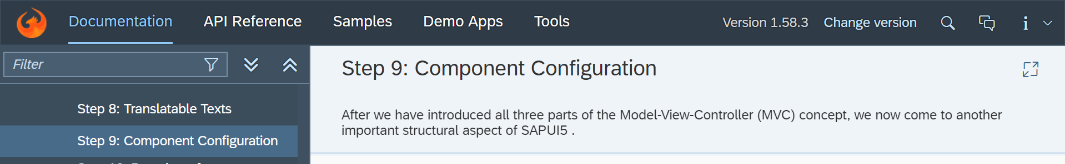

Core Codes:

Index.html

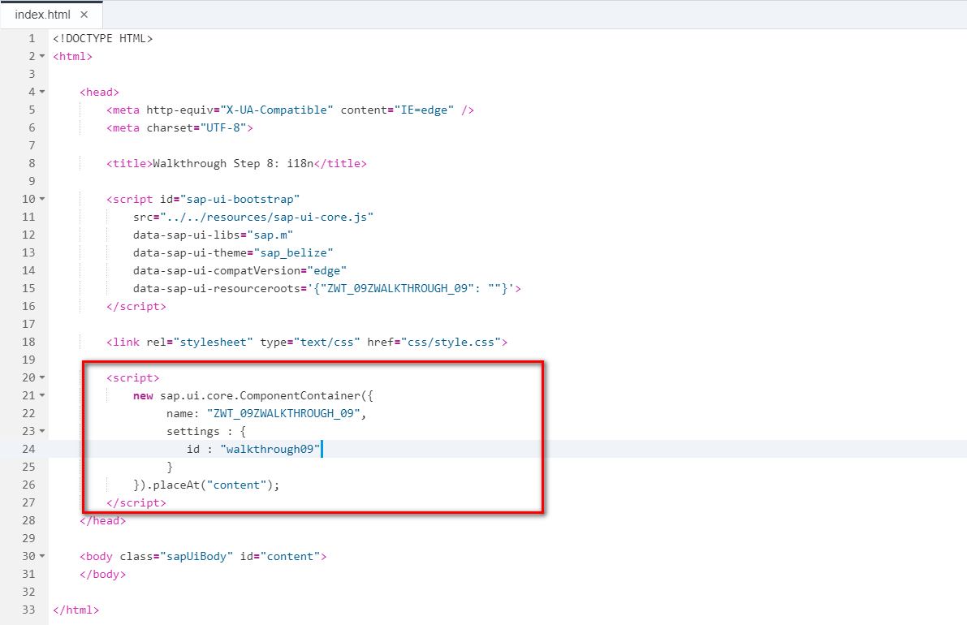

Controller.

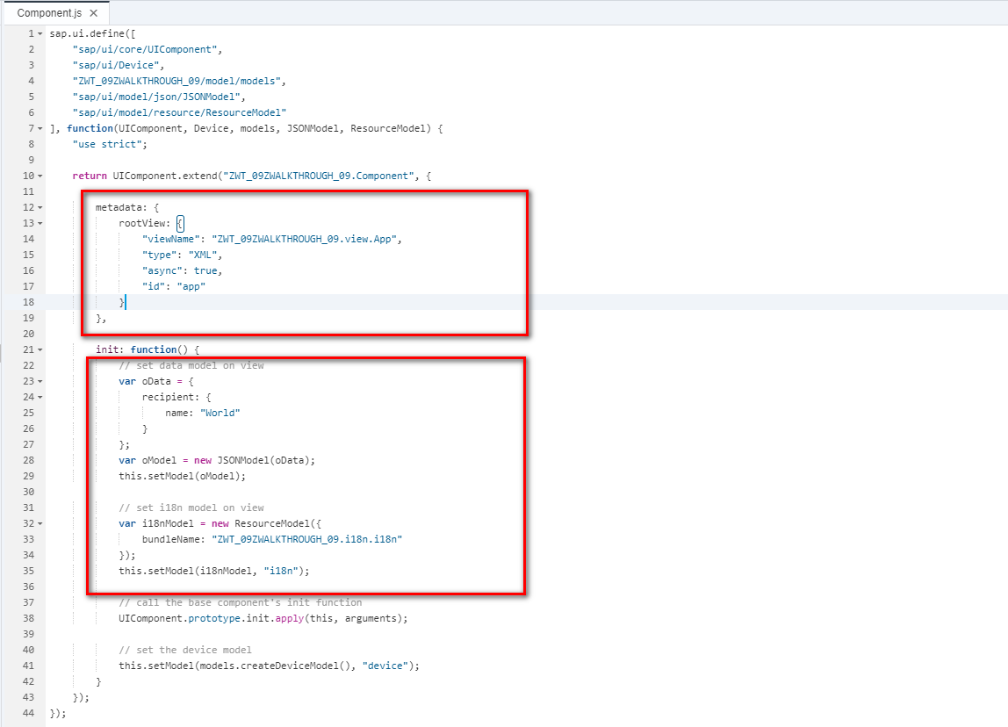

View.

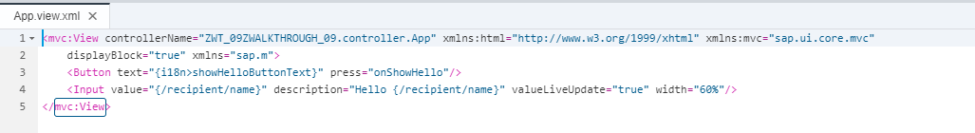

I18n



Result:

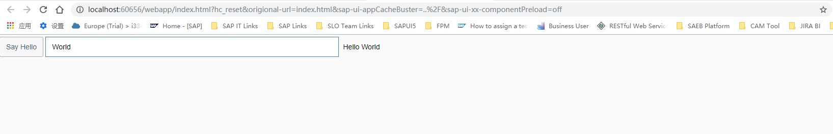

Git:

2018/11/02 XiaoMi Beijing Zac,Xie